**Chapter Two**

**1. Sensation and perception**

**1.1. Sensation and senses**

**Sensation:** - is the simple experience that arises from the stimulation of the sense organs.

* Or it is the transmission of information from the environment to the brain.
* Or it is the process by which our sensory systems (eyes, ears and other sensory organs) and nervous systems receive stimuli from our environment.
* Sensory processes tell us what is happening, both inside in our bodies and in the world that exists beyond our own skins. Without sensation, we would lose touch - literary with reality.
* At some point you probably learned there are five senses corresponding to five sense organs that are vision (eye), hearing (ear), smell (nose), taste (tongue), and touch (skin) but actually there are more than five senses, even though scientists disagree about the exact number.
* For instance, the skin, which is the organ of touch or pressure, also sense heat, cold, and pain, not to mention itching and tickling.
* The ear, which is the organ of hearing, also contains receptors (called *vestibular* senses) that account for the sense of balance.
* Vestibular senses inform us about the movement and stationary position of the head.
* The skeletal muscle contains receptors (called *kinesthesis*) responsible for sense of bodily movement.
* **Sensation** in general begins with the sense receptors; cells located in the sense organs when these receptors detect an appropriate stimulus (light, mechanical, pressure or chemical molecules), they convert the energy of the stimulus in to electrical impulse that travel along nerve to the brain this process is called ***transduction****.*
  1. **Measuring the Sensitivity of Sense**

The sensory laws: Sensory thresholds and sensory adaption.

There are certain sensory laws that explain how sensation works. Sensory threshold and sensory adaptation are the two general laws of sensation.

Studying the sensitivity of our sensory systems helps us to provide framework for understanding how they operate.

1. **Absolute Threshold** – is the minimum stimulation needed to detect a particular stimulus or it is the least amount of energy in order for a sensory system to detect it.

* Reliable detection is said to occur when a person can detect a signal 50 percent of the time.
* By studying absolute threshold, psychologists have found that our senses are very sharp indeed. If you have normal sensory abilities, you can detect the following thresholds though they vary from person to person.

2. **Difference thresholds/just noticeable difference (jnd)/**

* It is the smallest difference in stimulation that a person can detect reliably half of the time.
* Or the minimum difference that a person can detect between two stimuli
* Psychologists study sensitivity by having people compare two stimuli and judge whether they are the same or different for example a person might be asked to compare the weight of two blocks, the brightness of two lights or the saltiness of two liquids.
* Internal noise, external noise, and experience level of fatigue, expectation and motivation of the person can affect the detection of the threshold.

**1.3. Signal detection theory**

- Set of formulas and principles that predict when we will detect the presence of faint stimulus (signal) with a mid-background stimulation (noise).

* According to signal detection theory, an observer’s response in detection task can be divided in to a *sensory process*, which depends on the intensity of the stimulus, and a *decision process,* which is influenced by the observer’s response bias.
* Methods are available for separating these two components. The information can be fed in to a mathematical formula that yields separate estimates of person’s response bias and sensory capacity. The individuals’ true sensitivity to a signal of any particular intensity can then be predicted.
* The old method of measuring thresholds assumed that a person’s ability to detect a stimulus depends solely on the stimulus. According to the theory, detection depends on the qualities of the stimulus, the environment and the person who is detecting. That means signal detection formulas consider *three* kinds of variables. These are:
* ***Stimulus variables*** *–* the types and natures of stimulus.
* ***Environmental variables*** *–* how much noise or destruction is there.
* ***Organismic variables*** - the person doing the detecting is properly trained, motivated, healthy and alert.
* So, signal detection theory is preferred than absolute and differential thresholds to measure the sensitivity of senses.

**Sensory adaptation-**is the diminished sensitivity as a result of constant stimulation.

* When a stimulus is unchanging or repetitive, sensation often fades or disappears.
* The resulting decline in sensory responsiveness is called sensory adaptation.
* Such adaptation is usually useful because it spares us from having to respond to unimportant information.

**Sensory Deprivation**- is the absence of normal level of sensory stimulation.

* Human brain requires a minimum amount of sensory stimulation in order to function normally. If it is too low, it is bad for the brain to function properly.

**Sensory overload –** is expensing too much amount of stimulus from the environment. This is also bad for the brain to function properly.

* Generally, too little stimulation (sensory deprivation) and too much stimulation (sensory overload) can lead to fatigue and mental confusion.

2. **Perception**

* **Perception** – is the process of organizing, interpreting and integrating of incoming sensory information. Or the understanding of the information that is detected by our senses.
* In the brain, sensory signals that give rise to vision, hearing, taste, smell and touch are combined from a movement to produce a unified model of the world this is a process of perception.
* Perception consists of *three* basic processes. These are:
* *Selection*
* *Organization*
* *Interpretation*

***1. Selection***

– It is the first step in perception in which we select the stimuli to which we will attend. In almost all situations there is an excess of sensory information, but the brain manages to sort out the important message from the senses and discards the rest this process is known as *selective attention*.

* In general, there are environmental, psychological and physiological factors that influence the process of selective attention.

1. **Environmental /Stimulus/ Factors**

* Generally, the focus of attention is attributed to objects or events that possess unusual characteristics or that provide strong stimulation to the sense organs.
* Some of these qualities of objects or events are the following:
  + ***Intensity*** - the more intense the stimulus the more it will be attended.

E.g. the brighter light is more attended than the dull one.

* ***Size*** - the larger the size of the stimulus the more we give attention and the smaller the size we give less attention.
* ***Contrast*** – what contrasts with the surrounding environment attracts attention easily.

E.g. If one stranger and teacher are entering in the class, the students give more attention to the stranger and less attention for the teacher.

* ***Repetition*** – the more repeated the stimulus, the more we give attention.

E.g. Advertisement of one company which is repeated regularly.

* ***Movement*** – something, which moves, is more likely to attract attention than something stationary.
* Human beings as well as animals are quite sensitive objects that move with in their field of vision.
* ***Novelty***– A sudden or unexpected stimulus is more likely to catch our attention more easily than the one we have been expecting or that we have encountered.

1. **Psychological Factors**

What are some of the internal psychological states of the observer that affect as to which stimulus on pays attention to or ignore?

The focus of attention also affected by the characteristics of the individual. Some of these are:

* + ***Motivation*** – largely our current level of satisfaction or deprivation determines what we choose to hear or perceive.

- People in need are more likely to perceive something that they think it will satisfy that need.

E.g. when you are hungry, you are likely to give more attention to food advertisement rather than car advertisement.

* + ***Emotion*** – your current feeling, mood or mental state affect the kind of stimulus we select.
  + ***Personality and Interest*** – individuals select the stimulus and give attention if they are interested.

E.g. In the football game a person may give attention to the football game his wife may give attention to the music in the stadium.

* ***Previous Experience*** – the work place, expectation and past experience affects the selection of the stimulus. In general, previous experience affects perception because of the effect of perceptual set (expectation about what you would see).

Psychologists have identified another important psychological factors: These are:

* **Set or expectancy and motives or needs.**

Set refers to the idea that you may be ―ready and ―Primed for‖ certain kinds of sensory input. Set, or expectancy, therefore, varies from person to person. It is important not only in the selection of sensory input for inclusion in the focus of your attention. It is also important in organizing the selected sensory input.

To illustrate the role of set in attention, consider the husband who is expecting an important phone call. He will hear the telephone ring in the night while his wife does not. The wife, on the other hand, may more likely to hear the baby crying than the telephone ringing.

* **Motives and needs** are the second psychological factors influencing you as an observer. There are differences between you and your friend in what you select to perceive as a result of differences in your motives and needs. You and your friend attend to and organize the sensory input in ways that match your respective needs. People who are hungry, thirst, or sexually aroused are likely to pay attention to events in the environment, which will satisfy these needs.

C**. Physiological Factors**

* **Biological habituation** – Habituation is a tendency to ignore environmental factors that remain constant.

- The brain seems “programmed” to pay more attention to changes in the environment than to the stimulus that remain constant.

* **Feature Detectors (Feature Analysis)**-specialized cells in the brain that respond only to certain sensory information.

**2.Perceptual organization**

- Organizing stimuli in to patterns or shapes. Once we have completed our selection of incoming information, we must organize this information in to patterns or principles that will help us to understand the world.

- Perceptual organization integrates sensation in to percepts (meaningful perceptual units, such as images of particular objects), puts these percepts on perspective and locates them in space and prevents stimuli from changing their appearance as the perceiver examines them from another vantage point.

Organization of sensory data can be divided in to the following areas:

A**. Form perception -** refers to the way sensations are organized in to meaningful shapes and patterns.

* Gestalt psychologists in Germany first studied form perception in the early 20th century. The word “gestalt” means pattern or order in German; these scientists emphasized that perception involves more than the sum total of sensations impinging on the sensory systems. In other words, the whole (perception) is more than the sum of its parts (sensations).
* The following are some of the ways we group stimuli in our effort to understand the world around us.
* **1. Figure-Ground Relationships**
* Gestalt psychologists pointed out that we naturally organize our environment in to figure-ground relationships.
* This principle says organization of visual field in to objects (the figure) that stand out from their surrounding (the ground).

E.g. the Jet flying across the sky, the airplane is the figure and the sky is the ground.

- Figures are closer, more easily remembered and seem to have a shape. If they move their parts move together relative to the background.

- In contrast grounds are formless, farther away and stationary.

- Some times the relationship between figure and ground is more ambiguous and produces reversible figures and grounds. E.g. military uniform



2**. Grouping**-the principle of perceptual grouping refers to the tendency to perceive stimuli as meaningful whole or patterns or grouping means placing items in to understandable sets.

- We see complex patterns of stimuli as unitary forms or objects because of such grouping.

**Principles or laws of Perceptual Organization**

The following principles guide the way we group stimuli. Which are called **organization principles**

* ***Proximity*** – The term comes from the word approximate, which means “close.” It states that objects /stimuli/ that are near each other in place or time tend to be grouped together even though they are dissimilar.

E.g. From the above example not only do football players wear the same uniform, but also other people who share the same bench perceived together because they are near one another.

* ***Similarity* -** states that objects that are alike in some way tend to be perceive as belonging together. Or we perceive images that resemble one another as being part of a group, even when they are physically separated.
* We place items that look similar in the same group this is easy to see in team contests.

E.g. All the football player of intelligence college wears blue shirts represents all wearing blue are player of intelligence college.

* + - * ***Closure*** – states that the brain tends to fill in the gaps in an incomplete picture in order to perceive complete form. That is, we tend to perceive a complete object even though parts of it may be obscured or missing.
      * ***Continuity/Good Continuation***/- states once an object appears to move in particular direction, your brain assumes that movement continues unchanged. Or states that lines, patterns and objects tend to be seen as continuing in one direction, even if interrupted by another objects.

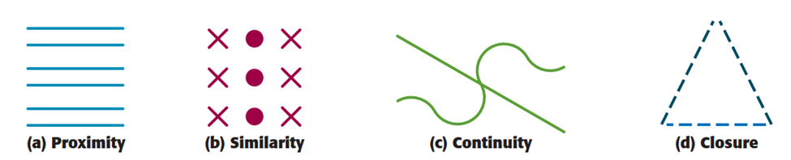

* + - * ***Common Fate*** – states that objects that move together in visual scene are perceived as a group.
* In the absences of any other organizing features, synchronous motion will create the perception of a group.
* For example, computer screen filled evenly placed dots will not generate any groupings. But as soon as some of the dots begin to move synchronously, they will immediately appear as a group regardless of where they are on the screen, how apart or how close together.



* ***Uniform Connectedness***- states that an object with a consistent texture, pattern or color is perceived as a unit.
* Some researchers argue that these gestalt principles overlook more fundamental characteristics of visual organization.
* **Law of Symmetry**:

This law states that people tend to perceive objects as symmetrical forms or figures. When the brain detects symmetry, it naturally assumes that parts of the object belong together, even if they are not directly adjacent to each other. Symmetry creates a sense of balance and coherence in the perception of objects.

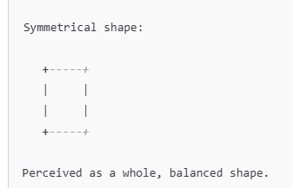

* 1. **Perceptual Constancy** – is the perception of objects as relatively stable, unchanging, despite changes in the stimulation of sensory receptors or changes in distance, angle of view or level of lighting of an object.

E.g. if you park your car and walk away from it, its retinal size continuously decreases and appears like a toy car. But you would not perceive the car as a toy car, rather you would know that the decrease the car’s size was the increased in distance.

- Perceptual consistency means perceiving the properties of an object remains the same even though the physical properties of the message are changed. There are different kinds of perceptual constancies. These include:

I*.* ***Size Constancy*** – states that we continue to perceive familiar objects as having a constant size even when its retinal image becomes larger or smaller as we get closer to or farther from it.

- Objects that appear big are close and objects that appear small are distant.

- For instance consider your friend coming in view at the end of the street. Because she is at distance she appears quit small. But she appears to grow larger and larger. Is she getting bigger of course not! But she is getting closer.

- In Conclusion the actual size of an object is not changing at all but what is changing is the distance.

*II****. Shape Constancy*** – assures us that we continue to perceive familiar objects as having constant shape even though the shape of the retinal image produced by an object changes when our point of view changes.

E.g. a closed door viewed straight on appears rectangular but if you open your door, the rectangle will look like a trapezoid despite the change appearance, you will have no doubts about the shape of the door. You realize that it is because of viewing angle.

*III.* ***Brightness Constancy*** – states that we continue to see objects as having relatively constant brightness even though the amount of light they reflect changes as the over all level of illumination changes.

E.g. If you look at a sheet of typing paper in bright sun light, it appears blazingly white; view the same paper in a dimly lit room and it appears gray so, we know that the “white” paper stays constant no matter what the lighting conditions are.

*IV.* ***Location Constancy*** – we perceive stationary objects as remaining in the same place despite the retinal image moves about as we move our eyes.

*V.* ***Color Constancy*** – refers to the tendency to perceive the color of objects as stable despite the changing illumination.

**C. Distance and Depth Perception**

- Our remarkable ability to judge accurately how far objects from us and from each other is referred to as depth or distance perceptions.

* **Depth Perception** – our ability to perceive objects in to three dimensions. It protects us from falls.
* **Distance Perception** – our ability to judge the distance between objects and ourselves.
* There are two kinds of visual information about depth and distance.

1. **Binocular Cues-** depth cues in which visual input integrated by using both eyes.

**Sources of Binocular Cues**

Convergence, Retinal disparity and Accommodation

* **Convergence** – binocular depth cues related to the tension in the eye muscles when the two eyes track inward to focus on objects close to the viewer.
* **Retinal Disparity** –A binocular depth cues that indicates the difference between the images you see with the retinas in your left and right eyes.
* **Accommodation** – objects at different distances cause the lens to assume different shapes to minimize visual activity. Surrounding muscles adjust the shape of the elastic lens in order to focus on nearby or distance objects.

1. **Monocular Cues** –distance cues in which visual input from a single eye alone.

* Monocular cues are more important for far objects to judge simply.
* There are quite a number of these cues. These includes the following:
  + - * ***Linear Perspective*** – when two lines known to be parallel appear to be coming together or converging implies the existence of distance. Or it says parallel lines seem to draw together in the distance. E.g. when you observe at distance roads, railways etc…are seems draw together.

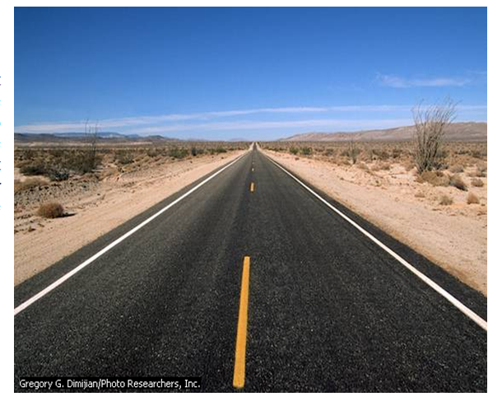

* + - * ***Interposition (Overlap***) – This cue realizes that closer objects partially obstruct /covers/ the view of more distant objects. Or if one object blocks or partially covers the other, the blocked object is perceived as more distant. 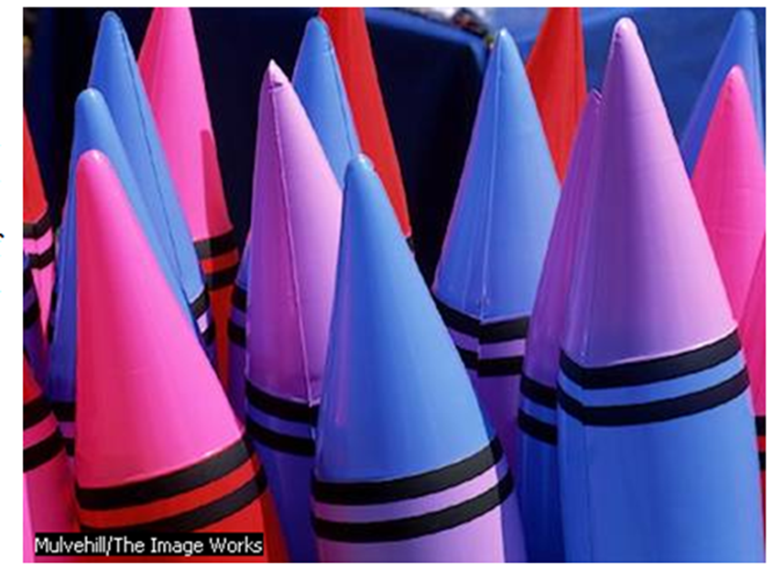
      * ***Relative Clarity***- objects that are faraway look like fuzzy, blurred and have hazy appearance in comparison to near objects because of moisture and dust in the air.

If you see far objects at a distance area they look like cloud, so you can conclude that the objects are far away.

* + - * ***Relative Size*** – these depth cues say, if an object of known size appears large, it is probably close, and if an object appears small, it is probably distant.

E.g. passengers’ jet passing over your home at 40,000 feet appears so tiny it is hard to believe that is holds full sized people inside. But you know the real size before and you conclude that the plane is far away.

* ***Relative Motion*** – refers to the apparent slowness indicates an objects is distant. If a jet passed 20 feet over your house it is not only would appear large but also would appear to moving exceptionally fast.
  + - * ***Relative Height (Elevation****)* –Distant objects appear higher in your field of vision than close objects do.
      * ***Light and Shadow*** – according to this view brighter objects are perceived as closer while darker or dimmer objects are perceived as farther away. Drawers use this cue to represent such things.
      * ***Texture Gradient*** – Distant objects usually seems to have much smoother texture than near by objects or the denser and fine the texture becomes, the more further away it is from the observer.

- For instance when you observe korekonch roads, it is rough when you see nearly and it seems smoothly when you far away from it.

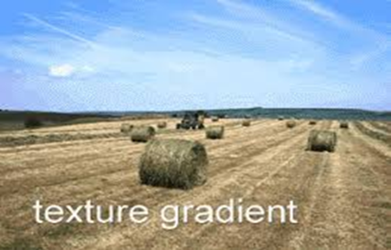

D. **Motion /Movement Perception** -there are two kinds of movements. These are:

1. **Real Movement** – The perceptions of real movement is the result of an actual change in the objects position in space. Basically there are two ways in which we perceive real movement.

* An image moves across the retina.
* The eye moves in the head, to follow the path of the moving objects

2. **Apparent Movement** – occurs when an object is static but we perceive it as moving or we perceive objects without physical motion sometimes called *visual illusion.*

* Sometimes we perceive motion when there is none but these mistakes are not all bad. There are three major types of apparent movements.

1. ***Stroboscopic Motion /Phi phenomenon****/-*the ability of the two eyes to see over lapping but slightly different views.

E.g. If you set in a dark room and look at two adjacent lights being turned on one after the other it will seem that a single light is jumping back and forth. 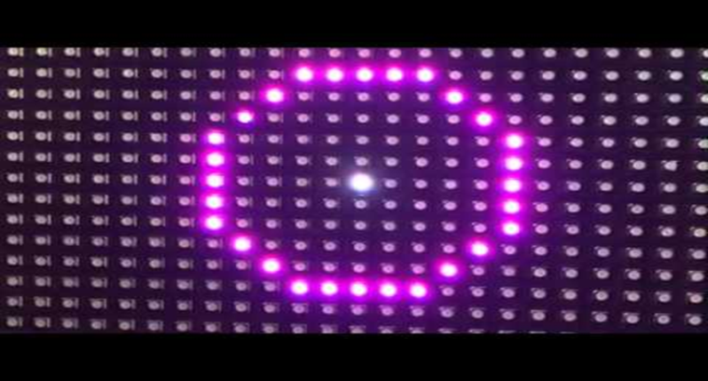

1. ***Auto kinetic Motion*** – it is a perceived motion of a single stationary light or object. You can experience this illusion by looking at a small dim light at the far end of a completely dark room

E.g. If you put a piece of lightened cigarette in a dark room and see at a far distance, it seems moving but not move.

*c)* ***Induced Movement*** – It occurs if a stationary spot or objects is perceived as moving when its frame or background moves.

E.g. when the moon is often perceived as moving behind a thin layer of clouds actually the moon is relatively stationary and it is the moving clouds, which induce movement on the moon.

**Visual Illusions (Perceptual Illusion)- when seeing is misleading**

visual illusions are visual stimuli in which the cues used in visual perception create a false perception.

It occurs when your perceptual experience of a stimulus is substantially different from the actual stimulus you are viewing.

It is an inappropriate interpretation of the physical reality.

We experience a number of perceptual illusions in our day to day life.

Müller-Lyer Illusion Devils Tuning Fork

Panzo (Zöllner) Horizontal / Vertical

Moon illusion Triangular illusions are the common ones

**3. Interpretation**

*-* After selectively sorting through in coming sensory information and organizing it in to patterns, the brain uses this information to explain and make judgment about the external world. This final stage of perception is called *interpretation.*

- Interpretation is affected by belief, culture, mood, emotion, perceptual set/ expectation, motivation, experience and need/.

**Extra Sensory Perception (ESP)**

* It is defined as perception that does not require stimulation of a sense organ. Or perception without sensation Generally extrasensory perception break down in to *four* main categories.

1. ***Telepathy/ Mind Reading/*** – is a transfer one person’s thought to another as in remote viewing.

* Or it is a direct communication from one mind to another without usual visual, auditory and other sensory signals.

1. ***Clairvoyance*** - is the ability to perceive objects or events not present or not affecting the person’s senses.

* Or it is the perception of an event or fact without normal sensory input.
* A person claims to tell something happen without any kind of information e.g. person may say my uncle comes at this movement.

1. ***Precognition*** – the ability to perceive future events. E.g. predictions of metrologists and magic man about the future.

*4****. Psychokinesis*** - the ability to move objects without touching them in any way.

